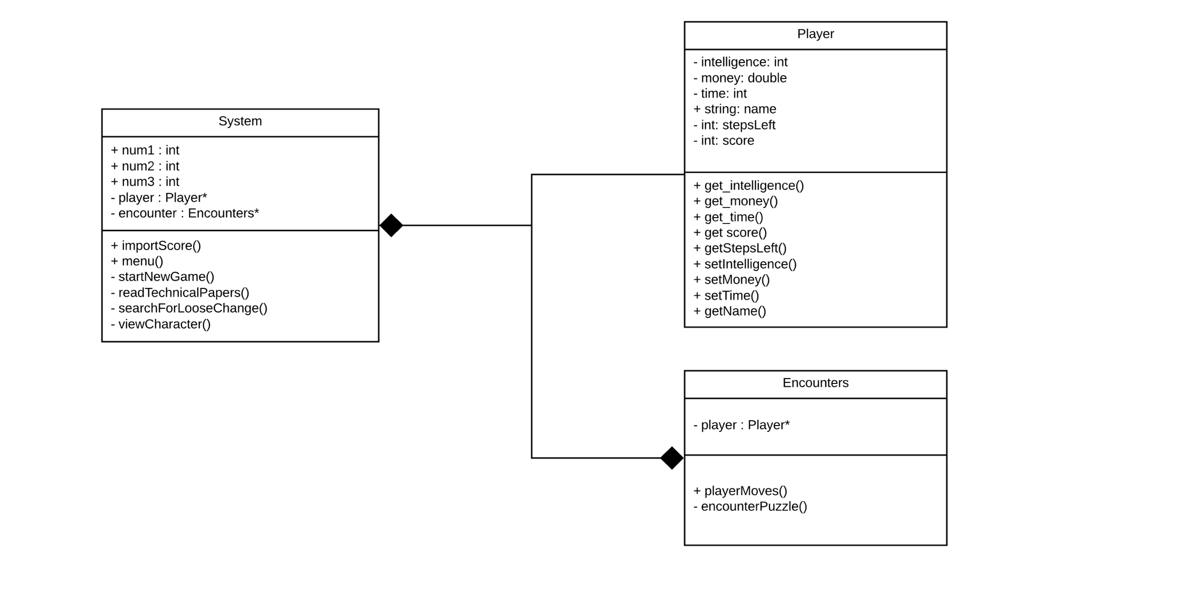

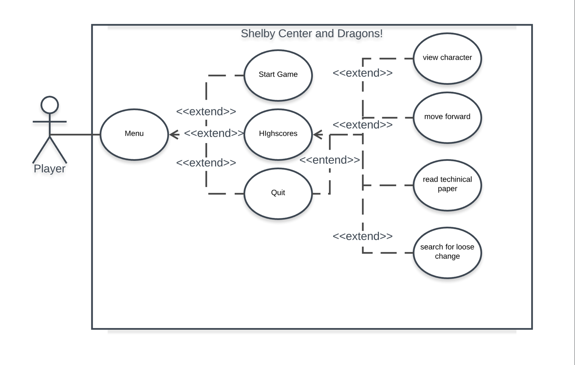Test Cases:

1. Need to test that character attributes instantiate correctly
2. Test each encounter and puzzle for probability and functionality (including any possible errors)
3. Test read technical papers and search for loose change for probability and to make sure it updates player attributes accordingly
4. Test high scores to make sure it reads in file correctly and checks and/or updates the file correctly with new scores
5. Need to test start game to make sure everything instantiates correctly to the proper value and that all functions work after it (i.e. encounter, read technical papers, etc.)